Chapter 4, Solution 28.

Convert the dependent current source to a dependent voltage source as shown below.
1 Ω
+
_
4 Ω
8 V
V_{o}
i_{o}
3 Ω
–
+
_
V_{o}
+

Applying KVL,
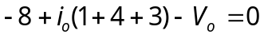
But 